 | Stalham Academy  Old Yarmouth Road, Stalham, Norwich, NR12 9PS  Tel: 01692 580053  Email: office@stalhamacademy.co.uk | 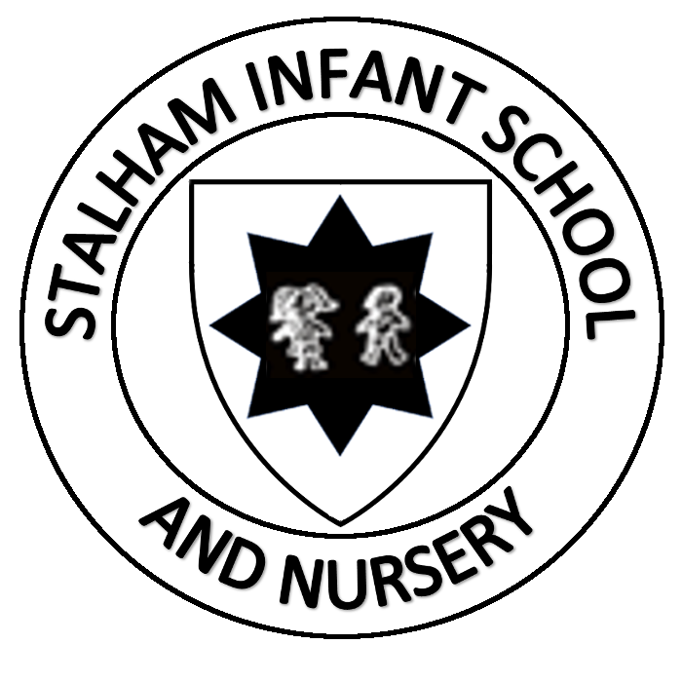 | Stalham Infant School & Nursery  Brumstead Road, Stalham, Norwich, NR12 9DG  Tel: 01692 580557 (School)  Tel: 01692 580311 (Nursery)  Email: office@stalhaminfantacademy.co.uk
Mr Glenn Russell : Executive Headteacher
Miss Ella Barnes: Deputy Headteacher

4 September 2020

Dear Families

Re: Drop-off and Collection Processes

I do hope that you are all safe and well and are looking forward to the new school year. Here at Stalham Infant and Junior Schools, we have been working very hard behind the scenes to ensure that the schools and site are as safe as they possibly can be in preparation for the children’s return to school on Monday 7 September.

We have recorded a series of drop-off and pick-up videos for you. These videos are for you to share with your child(ren) to show them what the drop-off and pick-up routines will look like for their particular year group.

If your child is in the Nursery, Year R, Year 1 or in Year 2, please watch the following videos:
- Infant school drop off
- Infant school collection

If your child is in Year 3, 4, 5 or 6, please watch the following video:
- Junior school drop off

As we have indicated before, there can be only one parent onsite for drop off and collection and you need to leave the site as soon as you can.

We are all very excited for the new term and have missed you all so much; we can’t wait to get the children settled and back to their learning.

See you all very soon!

Yours sincerely

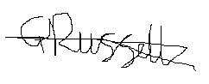

Mr Glenn Russell
Executive Headteacher

